THE NABI MUHAMMAD AS – SOME GLIMPSES
Muhammad, however, was responsible for both the theology of Islam and its main ethical and moral principles. In addition, he played the key role in proselytizing the new faith, and in establishing the religious practices of Islam. Moreover, he is the author of the Moslem holy scriptures, the Koran, a collection of certain of Muhammad's insights that he believed had been directly revealed to him by Allah. Most of these utterances were copied more or less faithfully during Muhammad's lifetime and were collected together in authoritative form not long after his death. The Koran therefore, closely represents Muhammad's ideas and teachings and to a considerable extent his exact words. No such detailed compilation of the teachings of Christ has survived. Since the Koran is at least as important to Moslems as the Bible is to Christians, the influence of Muhammad through the medium of the Koran has been enormous. It is probable that the relative influence of Muhammad on Islam has been larger than the combined influence of Jesus Christ and St. Paul on Christianity. On the purely religious level, then, it seems likely that Muhammad has been as influential in human history as Jesus.

Furthermore, Muhammad (unlike Jesus) was a secular as well as a religious leader. In fact, as the driving force behind the Arab conquests, he may well rank as the most influential political leader of all time.

It is this unparalleled combination of secular and religious influence which I feel entitles Muhammad to be considered the most influential single figure in human history.

Surah Al Ahzab – 33
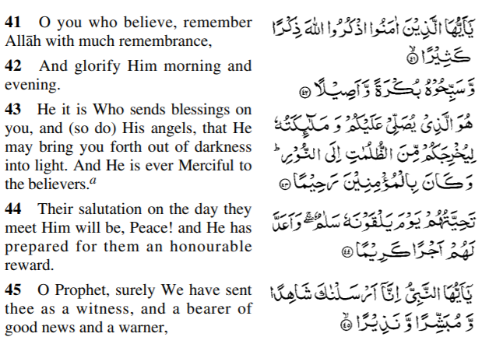
Surah Al A’araf 7
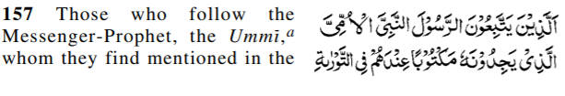
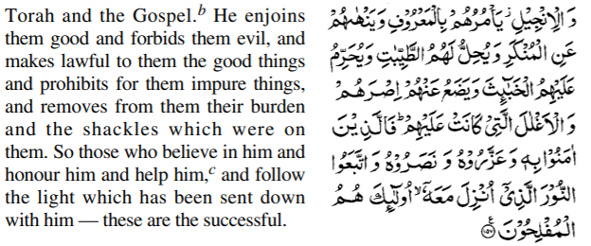
Surah Al Ahzab 33
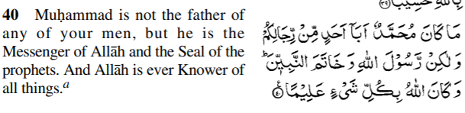
Al Fath 48
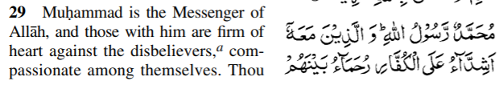
An Nisa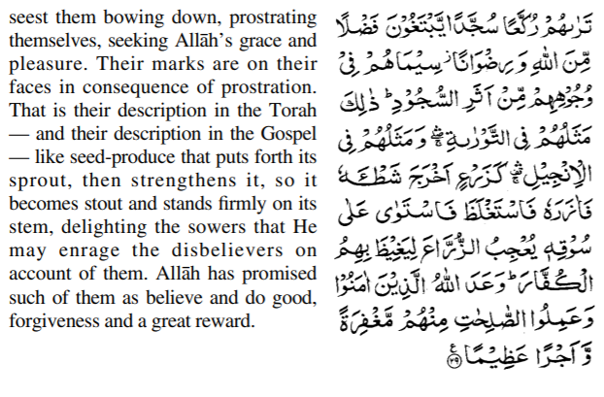
An Nisa 4
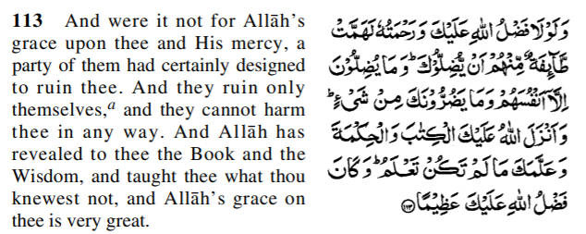
Surah Al Anam 6
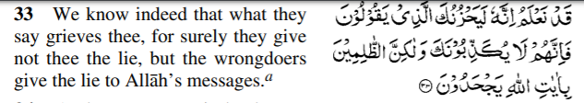
Surah Al Ahzab 33
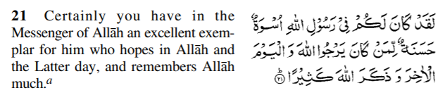
Al Furqan 25
