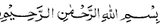
MIRACLE, DU’A OR MASHIYAT (WILL-AS INTENDED) OF ALLAH
IBRAHIM AS, ZAKARIYA AS, MARYAM AS AND ‘ISA AS-“GOOD NEWS FROM ALLAH”
(My Apologies to the readers-My intention was not to make this Paper Lengthy but one has to do justice to the queries that had been raised)
- IBRAHIM AS
Allah states in the Qur’an, concerning the knowledge that had been imparted to Ibrahim AS, In Surah 37 Verse 84:
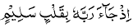 “He turned to his Rabb with a receptive heart; a heart that would bow down before the right and the truth without hesitation”. Allah had thought Ibrahim AS all the laws pertaining to the Universe and thus he was well aware of the laws of reproduction in man: This is stated in Surah 6 Verse 75;
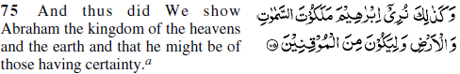 It is Allah who has created the universe most appropriately. He initiates creation according to His Amr (as explained in 2/117-below) every word of His is the truth. He has complete control over His creation. He infuses life into inanimate forms. He has knowledge of both the seen and the unseen and He is the Wise, the Cognisant.
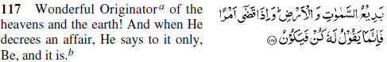
When Ibrahim AS has to use this knowledge, he has no hesitation as he is aware how the laws work. Allah sends the good news to Ibrahim AS in Surah 11 Verses 69-73:
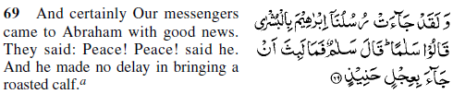
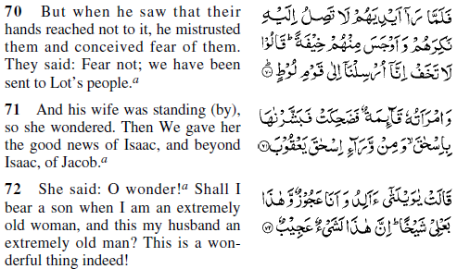Allah’s messengers came to Ibrahim with glad tidings and said, “Peace (on you),” and Abraham replied, “Peace (on you too).” To offer hospitality to his guests, Abraham served them a roasted calf. When he saw that they made no effort to partake of the food, he felt suspicious and became apprehensive. They said to him, “Do not feel apprehensive. We have been sent by Allah to the people of Lot” (15/51-77). They also stated, Ibrahim’s wife who was standing by: The messengers announced to her glad tidings that she would have a son - Ishaq, and that Ishaq would have a son - Jacoob. She laughed and said: “Ah! How can I have a child when my husband and I are so old? If it comes to pass, it would indeed be extraordinarily astonishing.” The response from the Malaika was as stated in Verse 73:
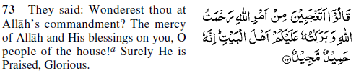They said, “Why are you surprised at Allah’s decree (); this (in fact) is Allah’s Rahmat and blessings on you? O members of this household! Surely Allah is worthy of all Hamd and He is Sublime” This incident is repeated in Surah 51 Verses 24 to 30 and again Surah 15 Verses 51 to 56. Note in Surah 51 Verse 30:
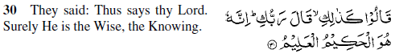 They said, "We have not told you this on our own, but this is the message from your Rabb that we have conveyed to you.” When this is the decision of Allah the Almighty, it is bound to happen. He also knows why you could not give birth earlier and how this capability can be restored in you.” It is important to notice the use of the word, in the above Verse and in Surah 6 Verse 75 above. It is translated as “thus” as if to say that you are aware of the laws pertaining this subject. There was no miracle but Ibrahim AS was aware of the steps he needed to take…..to fulfil the Du’a he had made to Allah in Surah 14 Verse 39:
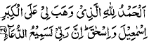” Hamd is due to that Allah who has granted me in this old age Ism’ael and Ishaq. I am certain that my Rabb will hearken to my petition.” And when he gets the good news he follows the law that Allah had thought him.
Please note some interesting facts:
- Isma’eel was the first born if Ibrahim AS whose age at the time was 86. (Torah)
- Ishaq was born when Ibrahim was 100, 14 years later. It was only then he left for the Hijaz. (Torah)
- Ibrahim AS only took Isma’eel to the Hijaz after Ishaq was born. So where is the baby Isma’eel and the zam and Harare running from Safa to Marwa…..just a thought, eh! (Refer Ibrahim AS’s Du’a wherein he refers to Mecca as a city. The Qur’an clearly states that when Ibrahim AS dreamt of the Zabaha, Isma’eel was a baligh (young man). Surah 37 Verse 103: When the son grew up he was able to render help to his father…the rest of the story we all know; Except that the word Zabaha is used and not “Qurbani” (sacrifice – such sacrifices do not exist in Islam) in the follow-up story………..
- There is no mention of two wives of Ibrahim AS, Hajara and Sarah, this is only mentioned in the Torah, which we know was changed by the Jewish Rabbis to suit their story. This is what Bukhari and his mates borrowed from, which is Israeliat folklore.
- NB. No argument of Immaculate conception here.

F) DISCUSSION POINT – DU’A!
If we look at Chapter 14 Verse 39 above we notice that the phrase “” actually refers to a supplication that Ibrahim AS had made for a son. The question that arises is that when the said Du’a bears fruit, much surprise and apprehension is displayed by Ibrahim AS and his wife (refer Surah 11 Verse 69 to 73). Here is a Nabi who makes a supplication to Allah and when The Du’a is responded to there is a display of incredulous behaviour. Why? Are we missing something in the whole process of Du’a? Or was the process of 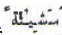Mashiyat (see below) had to be activated by Ibrahim AS. And his wife. See explanation above.

As an aside, if we look at Surah 14 Verses 35 to 38, Ibrahim AS, after the building of the Kaaba makes a supplicant to Allah to make the city a sanctuary for all of mankind who will be going there for Hajj. The question again arises that No Hajji has even stated that they were going to Mecca because of the Du’a of Ibrahim AS; or that Allah has caught anyone by their ear and forced them to go there (if Allah acts as such). In addition Mecca has ceased to be a place of sanctuary for mankind (only Muslims go there for the purpose off rituals) by a long shot and after the Khulufa-e-Rashideen was never regarded as a headquarters (UN) for mankind. All it means that it is man that needs to put that right and not rely solely on Allah. Allah will assist and guide.

g) EXPLANATION OF MASHIYAT 
Before we proceed any further on this discussion, a brief input is required on this subject as its understanding is important for the subjects we are having a discourse on. When I say brief, I mean brief, because the explanation of, Mashiyat is over 8 pages in fine print. Someday we can look at all the 8 pages.
This is from the Root  meaning to plan and to originate according to that particular plan. According to Raghib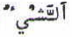, As Shayun would be used for all that is present, whether physical or perceptive. The influence of would be with detail knowledge of the particular thing either from within or externally, through Wahi. As far as Ambiya are concerned they have this knowledge from Allah via Wahi. In Surah 2 Verse 20 Allah states: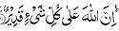 Loosely translated: Surely Allah has power over all things” and could be explained thus: Surely Allah has prescribed Laws for all events in the universe and Allah does not infringe upon these Laws even though He has the power to do so. And again in Surah 36 Verse 82 He states:
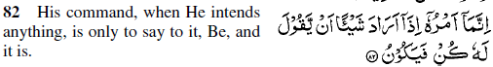He does not have to bring any raw material from anywhere for the purpose of creation. His Law of creation is that, whenever, He wills something, the process of its creation is initiated right away. On the above explanation one could explain as meaning to have an intention that results in realisation. Laws are observed easily in the physical world, but it also has its manifestation in the social and moral world and given to man though Wahi. In Surah 33 Verse 39 Allah states:
, Meaning: “Such has been the way of Allah with those who had gone before. And the command of Allah is a decree that is made absolute….” In Surah 2 Verse 142 Allah states:
And very incorrectly translated “He guides whom He pleases to the right path.” In the context of this subject it really means: “The person who is desirous of the guidance of Allah (and obviously strives towards it) will receive it thus , will mean “the person who desires” and not “the person that Allah wishes to….” One must take care not to use the common phrase that “Allah guides whom He wishes and Misguides whom He wishes”, sic. One should refer to “Kitab-ut-Taqdeer” (400 pages: Yusuf, I still have your notes on the talk you gave on Taqdeer in Masjid-ul-Islam –sad to say the standard has deteriorated at the Masjid, these days) for a very detailed explanation of this subject, and also refer the “Lughat-ul-Qur’an”…..Thus negates all concepts of miracles. Some linguists take Arada and to be synonymous but the former is to intend to do and the latter is the realisation of that intention, or plan, that is why in most cases the both are used together as above in Surah 36 Verse 82.

Now back to the subject……..
2. ZAKARIYA AS
In Surah 3 Verse 38 Zakariya AS makes Du’a to Allah:
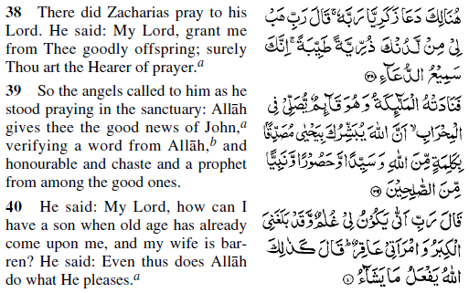Until that time, Zakariya had no children. Raising Maryam as his own child evoked in him the desire to have a child of his own. So he prayed, “O my Rabb! bestow on me, out of Your Grace the gift of a virtuous offspring – You, indeed hear all supplications.”
Whilst he was still praying in the temple, the Malaika said to him, “Allah has sent you the glad tidings of the birth of (a son) Yahya (John), who will testify to the Words of Allah (Wahi). He will be a great leader maintaining discipline amongst his followers and (a person with outstanding capabilities; in short) from among the S’aliheen.”
Zakariya said, “How can I have a child when old age has already overtaken me and my wife is barren?” (Will the child be an adopted one like Maryam or will it be my own? The answer was, “No, the child will be your own son.” (The physical defect of barrenness was removed as stated in Verse 40 above through the Mashiyat of Allah due to which Zacharias’s wife could not have Zacharias’s child, and she gave birth to Yahya in due course of time; See below also). Allah said it would be like that as Allah does what He wills.
Surah 21 Verse 90:
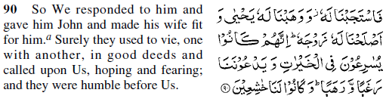We responded to his call and cured his wife (of infertility) and bestowed on him a son (of the stature of) John. All these Anbia aggressively pursued everything that was for the benefit of humanity; and sought guidance from Us in all walks of life, whether conditions were good or adverse. They waited for directions from Us and obeyed them, because they were aware of the dangerous consequences of taking any step against the Divine Laws. They were always fearful of defiance.
The curing of the infertility of Zakariya’s wife and the barrenness of the wife of Ibrahim AS was no miracle but that Allah brought about a cure through means that Ibrahim AS was thought (Refer above explanation of Surah 6 Verse 75) not only to Ibrahim AS but as stated all Ambiya were scientists of their time, through the knowledge of Wahi, and would have been well aware of medical needs and psychology etc. and acted accordingly. Let’s not lose sight of above meaning, “He said, thus Allah does what he intends according to His law.”
It is important to note that in Surah 3 Verse 39 the word Almehrab is used meaning the Santuary in the temple. This fact will help to understand why Maryam AS had to leave the sanctuary.

In Surah 19 Verses 2 to 9 the above incident is so related:
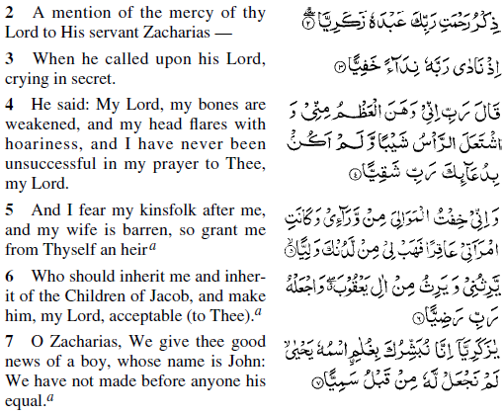
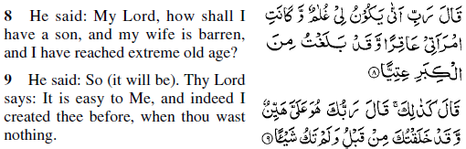 This is a narration of the bounties which your Rabb had bestowed on His devotee Zakariya. It so happened that Zakariya addressed his Rabb in a low submissive tone:
And said, "O my Rabb. I am growing weak on account of my old age and my head glistens with grey hair. Until now it has never happened that I have asked for something from you, my Rabb, and it has not been granted. (Therefore, I earnestly hope that this Du’a in my old age will also be granted graciously.)
(As I am old and) My wife is barren (and there is no chance of my getting any offspring). (I am thus apprehensive that) There is no one amongst my kinsfolk who is capable of carrying on the (dignified and distinguished characteristics of the) house of Jacoob. (I also fear that these may be lost and continuity may be disturbed.) So O my Rabb, out of your grace, grant me an heir who will be capable, worthy and deserving in all respects; so that I may entrust this heritage to his care.
(We heard his supplication and said) O Zakariya, We give you the good news of a son. When he is born he should be named Yahya (John). This boy will be very outstanding; and there has been none like him before (in your clan).
Zakariya said, "O my Rabb. How can I have a child when my wife is barren and I have become utterly infirm through old-age? (Will that child be born to my own family or will I adopt someone else's son, like Mary who is being brought up by me).
(His Rabb answered) “(No!), The child will be born as your own son; just as children are born (to other people). Reviving the potential of having children naturally, even in old age, is quite easy according to My Laws. I brought you into existence, although previously there was no trace of you.” Two points are worth noting in the Verses 2 to 9 above:
- 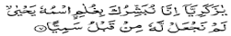The son will be your own son, Verse 7 and
- 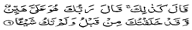 Will be born in the same way that you were born, Verse 9.
The above two Verses illustrate quite clearly that the process would be a natural reproductive process.
- Before progressing with the next heading a little bit of history would explain certain Verses from the Qur’an:
- House of 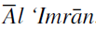and the title of Surah 3 is obtained from Verse 33, wherein the mother of Maryam is mentioned. , ‘Imran was the father of Moosa and Haroon AS and this lineage ended with Zakariya AS, Yahya AS and ‘Isa AS.
- History tells us: Joachim a wealthy farmer of Nazareth, and his wife Hanna (Anna) lamented over the fact that they had no children (from Protovangelium Jacobi discovered in the 6th Century by Postel and other sources). Joachim was told by Reuben, a Jewish father who could boast of numerous children, that his childlessness disqualified him from presenting his offering to Allah. Reuben looked Joachim in the face contemptuously and addressed him as a man “who had not given any off-spring to Israel.” With an aggrieved heart Joachim went to the Temple, remained there till late at night and prayed to the Lord to bless him with a child. In the meantime, Hanna, his wife, was also reminded of her childlessness as she saw, through the window of her house, a sparrow’s nest in a bush. She was also driven with jeers from the Lord’s Temple; Refer below – Du’a for Maryam Surah 3 Verse 34 & 35.

- Some Verse from the Qur’an explaining the Laws of Procreation:
Surah 36 Verse 36
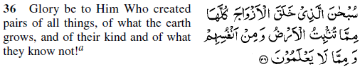Note the word
Surah 51 Verse 49
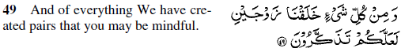Note the word. We should be mindful because the laws of Allah do not change-no exception. Also note Fruits-13/3; vegetation-20/53; animals-35/28, 42/11 and in
Surah 49 Verse 13
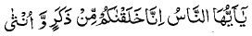O Mankind, surely, We have created you from a male & female. Note the word, “from”.
- Concerning change of Laws of Allah, refer some examples from the Qur’an:
Surah 6 Verse 34: 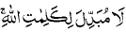 Nobody can change the laws of Allah.
Surah 30 Verse 30: 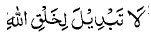Allah’s process of creation never changes.
Surah 17 Verse 77: You will not find a change in the working of Our Divine Laws.
Surah 35 Verse 43: 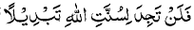So you can never find a change in the workings of the Divine Laws.
Surah 3 Verse 127: 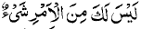Even the Messenger does not have authority to change laws of Allah. Refer for item g) above. Now on with the subject:
- NB. No argument of Immaculate conception here also.
- Once again one needs to point out that Surah 19 Verses 2 to 6 Zakariya makes a supplication for a son and then expresses surprise in Verse 6 when the good news is given to him. Here is a Nabi, once again, who makes a supplication to Allah and when The Du’a is responded to there is a display of incredulous behaviour. Why? Are we missing something in the whole process of Du’a? Or was the process of Mashiyat (see below) had to be activated by Zakariya AS. And his wife. See explanation above.
3. Maryam AS
Surah 3 Verse 35 & 36
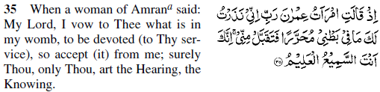
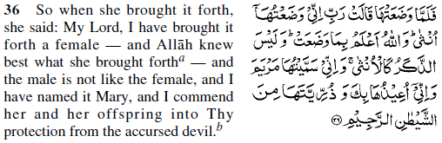This story begins when a woman from ‘Ale-Imran took a vow to dedicate her expected offspring for the exclusive service of Allah. She prayed, “O my Rabb! Accept my offering (because you know with what honest and sincere feelings I have made this offering-that is to serve the Temple as was the custom of the Jews – “Monasticism”). Surely You alone are All-Hearing, All-Knowing.”
She delivered a baby girl and thought inwardly that in order to fulfil her vow it would have been better if she had a boy. But Allah knew that this girl was to do what a boy could not do. She named her daughter Mary and prayed to Allah to protect her progeny from Shait’an – the accursed.
Allah accepted the offering graciously. Maryam was committed to the care of Zakariya and grew up to be a person of elegance and grace.” (History (Torah) tells us that Maryam was the cousin of the wife of Zakariya and thus the logistics, of her staying in the Temple, were acceptable.
One needs to remember, that Zakariya, was already in the Temple and the parents of Maryam wanted a male child for the same responsibility as Zakariya, but having given birth to a female, they were duty bound, per tradition of Jews, to fulfil their promise and allay the jeers of the people. But Allah had other plans. The piety and demeanour of Maryam was such that the priests already commenced fighting amongst each other for the care and responsibility of Maryam, which would give them status with the people, as is stated in Surah 3 Verse 44:
(O Nabi) “You were not with them when they vied with each other for the attention of Maryam and thus created divisions.” This competition for the attention of Maryam AS and the failure of the priests manifests itself when she returns after ‘Isa AS is born – Refer Surah 19 Verses 28 to 29, below.
NB. NB. No argument of Immaculate conception here also.

4. ‘ISA AS
i) News of a son to Maryam AS, Surah 3 Verses 45 & 46:
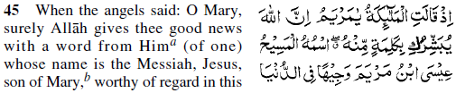
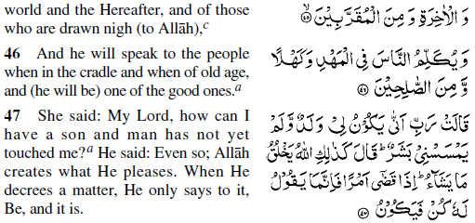Maryam had also been told that Allah had sent her the good tidings about the birth of a son according to His Laws. The son’s name would be the Messiah, ‘Isa – son of Maryam. He would be illustrious in this world and in the Hereafter. He would be most devoted to Allah. He would preach to people from an early age to an advanced age (5/100) and would be from amongst those who possess exalted qualities.
Maryam was surprised to hear this tiding about the birth of a son and said: “How can I have a son when no man has touched me?”; The answer was the same that had been given to Zakariya (refer above Surah 3 verse 39 and the explanation) namely, that the child would be born in accordance with Allah’s Law of Creation. And when He takes a decision about something, the initiation of the process starts forthwith.
Once again, refer in Verse 47 and note the meaning and explanation, here and above.

Now let’s look at Surah 19 Verses 16 & 17 on how the above was implemented:
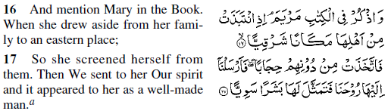(O Rasool!) Now relate from this Book (Qur’an) the story of Maryam, (starting from the time) when after abandoning her clerical life (of monasticism) she moved towards the east (to her village.)
(The clerical life and the unpleasant events occurring there had such an adverse effect on her mind that) There also she lived in seclusion, apart from others. In order to obliterate these effects, We introduced positive thoughts in her mind and pleasant aspects of life appeared to her (in her dream) as a person. On receipt of the first message from Allah (most likely from Zakariya) she now had to put the natural and reproductive laws into action and had to leave the sanctuary of the temple to do this. Even though she was not at ease as is illustrated in:

Surah 19 Verses 18 to 21:
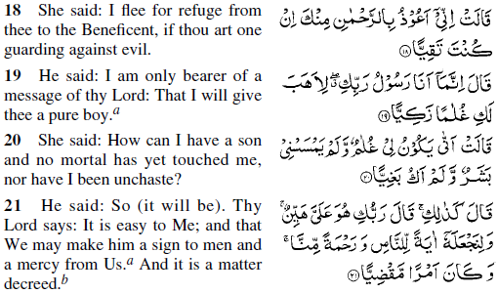(Maryam was apprehensive at the sight and exclaimed) "I seek the protection of Ar-Rahman from you (if you have any regard and respect for His Laws).”
He answered, "(There is no cause to become alarmed because) I have only brought a message from your Rabb (3:44). He is going to bestow on you a well-developed son.”
She said, "How can I have a son when no man has ever touched me.” (When I was in the temple, I lived a virtuous life; and since I came out, I have not got married as this is against the clerical laws.)
He said, "Whatever I have told you, will happen according to Allah's law of creation. This is easy for Him (to remove all the hindrances which are in your mind and which perturb you, Refer 19:9). Allah has also said that this child will not be like other children. He will be an embodiment of Rahmat for the people; and a testimonial for truth and falsehood. (Whoever brings Eiman on his Nabuwat will be on the right path, while the one who rejects it will be wrong.) And this is already decreed by Us (that the child will be Our Messenger, Refer 3:47).

Surah 3 Verse 59 - Like Adam
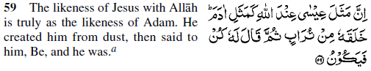 “The birth of ‘Isa is like the birth of any other human being. Life emerged from inanimate objects and passing through evolutionary stages culminated in human form. This is the truth from Allah and there is no room for doubt or dispute in this matter.” What must also be remembered that Adam in the Qur’an, with the exception of once, refers to “man” and the early Nabi amongst early man was related in Surah 3 verse 33:
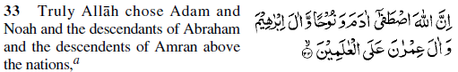

‘Isa Mentioned with Ambiya who had fathers and descendants Surah 6 Verse 85 to 87
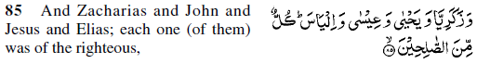
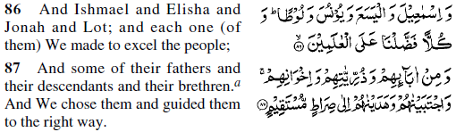 We gave to Ibrahim, Ishaq, Jacoob. Each of them We had guided as We had guided Nuh and his descendants. Similarly, We had guided Dawood, Suleiman, Ayob, Yusuf, Moosa and Haroon. Nabuwwat was bestowed upon them by Allah and they were compensated for the good lives they led. Also Nabuwwat was bestowed upon Zakariya, Yahya, ‘Isa, Elias. They were all S’aliheen. Isma’eel, Elisha, Jonah and Lot We favoured above the rest of mankind. And We also guided a right some of their fathers, offspring and brethren. We favoured them and guided them to the straight path. “Qur’an does not say “except ‘Isa”)

Further Qur’anic Evidence of natural Processes
Surah 16 Verse 72:
And Allah has created wives from amongst you.
And in Surah 6 Verse 99:
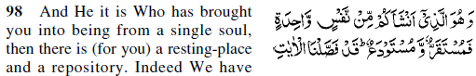
And it is He Who has brought you from a single kind, and there is a resting place and a depository; indeed We have made plain the communications for a people who understand (Meaning those who ma tadabbur on the Verses of the Qur’an).
This Verse refers to our creation from a single kind. The word used is nafs; which means, person, a thing, and essence, or a kind (and personality). The learned authors of Taj-ul-Arus, Tafsir-i-Kabir and Bahr-ul-Muhit explain this word as signifying “min Jinseha” – of the same kind. The Arabic word which have been translated as a resting place and a depository in the Verse above, are Mustaqarr and Mustauda respectively. The Imam Asir-ud-Din Abu Abdullah Muhammad bin Yusuf Ali Abu Hayyan who lived (654-754 AH) in Cordova, Spain, explains in his well-known commentary, Bahr-ul-Muhit that these words respectively mean the loins of the father and the womb of the mother and thus these words really stand for a male and female.
It is evident, therefore, that according to the Qur’an no procreation is possible without male and female agencies. The Qur’an lays so much stress on the Law of Procreation that it advances this very Law as an argument to refute the Divine sonship of ‘Isa AS as promoted by Christians – refer Surah 6 Verse 101 & 102.

i) Another Misunderstanding – ‘Isa talking as a child
Surah 3
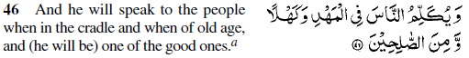He would be intelligent and have discussions with adults at a very young age and when he is old. (This is not surprising as even today we have little children who are geniuses-and with Allah this is easy-not miracle see below). The Qur’an refers to ‘Isa AS as being righteous. Speaking in the cradle means that he would be healthy and would live to a ripe old age and would have his senses about him all the time; Refer Surah 5 Verse 110.
Surah 19 Verse 28 to 29 – Read up to Verse 33 for the full reply of ‘Isa AS
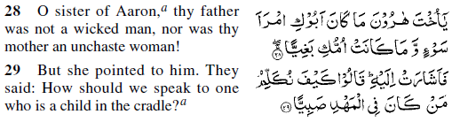They said, 'O sister of Haroon! Neither was your father a wicked man, nor had your mother revolted against the clerical discipline. (With such a noble, religious and law abiding ancestry, look at what you have done and the kind of education you have given to your son.)
In reply to all these questions she (would not say anything herself but) would direct them towards ‘Isa (to get their answers from him). (The elderly priests who were extremely proud of their priesthood arrogantly asked) Should they talk to one who till recently was a little boy in the cradle? Old and learned Jews (the Priests of the Temple Refer Surah 3 Verse 44 Above for their competition for Maryam’s attention) would no doubt speak of a young man who was born and brought up before their eyes as a child in the cradle, as if disdaining to address one so young (even today this kind phraseology is used), the Verses that follow clearly state that ‘Isa AS was an adult. Furthermore, it was their way of getting to Maryam for braking the age-old tradition of Monasticism which Allah was breaking down, which the Sufis have re-introduced in Islam sic.

A few words about the word almuhdi, from the root  which means to make a place soft and balanced, and because of this 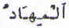almihad means a bed. In Surah 30 Verse 44:
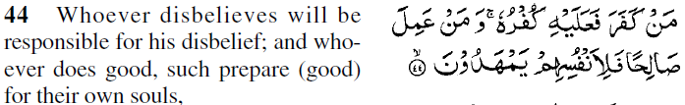Those who had rejected the Divine Laws will bear the burden of their denial, whereas those who had done righteous deeds, will get all the comforts of life. Thus the reference to ‘Isa AS as “a child in the cradle,” one though very young is fully balanced and intelligent and aware of good and evil.

v) Some History
i. Early Christians (Corinthus & Carpocrates) use Gospel of Matthew as “And Joseph begat Joseph and Joseph begat Jesus of Mary.”
ii. Clement condemned the early Christian for above statement and changed it to, “And Jacob begat Joseph, the husband of Mary, of whom was born Jesus, who is called Christ.”
iii. Discussing this change Rev. CJ Scofield in his Reference to the New Testament admits, “The changed expression was introduced to convey Jesus was not begotten of natural conception.”
iv. One of the copyists mad another alteration, “And Joseph begat Joseph, to whom was married the virgin Mary, begat Jesus.” Because of its awkward alteration the church at that time disowned it.
v. The early tradition believed that the name of Jesus’s mother was Mari and the name of his father was Joseph (Britannica). Christian apologists challenged the correctness of Joseph being father of Jesus.
vi. We are also told in Luke that Jesus was born after Mary’s “days were accomplished” just like John the Baptist was born after the full time of Elizabeth (wife of Zakariya). How is it that in case of a supernatural birth all the laws relating to a natural birth had to be complied with?” Refer Qur’an Surah 19 Verses 21 to 26, why did Allah not make it easy for her also.
vii. According to the Gospel of Thomas, Joseph was a carpenter. Jesus learnt his father’s trade. He, therefore, came from the ranks of the simple classes, from among those who laboured and “ate bread in the sweat of their faces.” He experienced their troubles and poverty as well as their hatred of the rich (Mathew).
viii. An angel of the Lord appeared to Zakariya and said, Zakariya go forth and assemble them that are bachelors of Israel, and let them bring every man a rod, and to whosoever the Lord shall show a sign, his wife shall she be (*Prot. Jac viii: 3; Evang, de Native, de Marc C. 7).
ix. So did Zakariya. And Joseph cast down his adze (carpenter’s tool) and ran to meet the heralds……the priests cast the rods into the fountain……when Joseph’s rod emerged a dove came down and sat beside it*. Joseph was then married to Mary (details in Armenian Version Ch. Iv) and after some time took her to his house in Bethlehem. The marriage is consummated and Mary conceives.
X. According to Mark vi-3; Matt xii-16 to 47; Luke viii-19; John ii-12; Acts i-19: When Mary returns with Jesus, people of Nazareth gather around saying. “Is not this the carpenter, the son of Mary, the brother of James, and Joses and Juda, and Simon? And are not his sisters also with us?
vi) ISRAELIAT
The immaculate conception of ‘Isa, his crucifixion, resurrection and ascension, are the essential features of Christianity; but not of Islam. They neither separately nor collectively form any part of the creed of a Muslim, nor do they touch any of the 5 Pillars of Islam. Christians, having hopelessly failed in establishing these ill-founded dogmas from the Gospels, have from time immemorial tried to support them by deliberately misconstruing certain Qur’anic Verses. Their object is two-fold, to deride and belittle the value of the Qur’an by asserting that, like the Gospels, the Qur’an also supports these absurdities and cannot, therefore, be a better guide to humanity; and secondly, they try to mislead the Muslims into believing that the Qur’an itself proves the Divinity of Christ.
Rodwell, in the Preface to his Translation of the Koran, states: “a line of argument to be adopted by a Christian missionary in dealing with a Muhammadan should be, not to attack Islam as a mass of error, but to show that it contains fragments of disjointed truth-that is based upon Christianity and Judaism, partially understood, especially upon the latter, without any appreciation of its typical character pointing to Christianity as a final dispensation.”
It is a notorious fact that in the first 4e centuries of Islam, after the demise of the Nabi AS, some Jews and Christians deceitfully joined the fold of Islam to undermine its very foundation. It is also true that the vast majority embraced Islam sincerely; but they unwittingly brought their traditions and stories with them, and these are known as Israeliat. Every student of Muslim history knows that these two categories of converts introduced by design or otherwise, the whole mass of their apocryphal literature in the commentaries of the Qur’an. The tales, stories and spurious traditions have been seized by Christian writers on Islam, Sale and Muir not excepted, and they have further distorted and fashioned the facts to suit the taste of Christians of Europe and elsewhere. They were as Sale confesses, out to expose the Holy Qur’an as a manifest forgery and for this purpose, did not hesitate to change the text (in their translation) of the Book. Mendacity and hypocrisy could go no further!
In regard to the above Some Muslims scholars, in exposing the Israeliat, have stated, as follows:
- Ibn-Khaldun in his Muqaddama states: “Their books and their reports contain what is good and what is bad and what may be accepted and what should be rejected, and the reason for this is: when these people (Jews & Christians) embraced Islam, they retained their stories which had no connection with the commandments of the Islamic Law, such as the origin of creation and the things relating to the future and the wars etc. Commentaries on the Holy Qur’an ere soon filled with these stories of theirs and as theses do not deal with Commandments, so their correctness is not sought after to the extent of acting upon them, and the commentators take them up rather carelessly, and they have thus filled yup their comments with them”.Vol 1 , 48).
- Hazrat Shah Wali Ullah, in his Hujjat-Ullah-al-baligha, gave the same warning, when he wrote: “And it is necessary to know that most Israelitish stories that have crept into the commentaries and biographies are copied from the stories of Jews and Christians, and no Commandments or beliefs can be based upon them.”
- Imam Ahmed Ibn Hanbal, declared that these commentaries and biographies “are not based on any principles.”
- Sir Syed Ahmed Khan, in his Khutabat-i-Ahmadiyya, condemned these commentaries and biographies.
- Moulvi Muhammad Ali stated that, “No Muslim scholar has attached the same value to the biographical reports. On the other hand all Muslim critics recognise that the biographers never made much effort to sift truth from error……In fact in some of the commentaries the reports cited are puerile nonsense. Even the Commentary of Ibn Jarir, with all its value as a literary production, cannot be relied upon.”
Although these commentaries and biographies are literary works of considerable merit, yet they express merely the opinions of their authors. We have the main Islamic source, the Holy Qur’an in its pristine purity, and we can check the correctness of these commentaries and biographies, and accept or reject them accordingly. In considering the various Verses of the Holy Qur’an we should not ignore the universally accepted rules of interpretation, nor indeed, should we overlook the fundamental and basic principles laid down by the Holy Qur’an itself, e.g.
All Ambiya were human beings
All Ambiya were servants of Allah
Laws of Procreation
All Human being must die.
Laws of Allah are Immutable. Etc,

This is my humble contribution to give some gleanings from the Qur’an on Miracles regarding the birth of certain very important persons mentioned in the Qur’an. The comments from the readers are welcome so that the discussion could continue. May Allah guide us all. In the process of doing the above, mistakes are inevitable, please forgive and correct.

Compiled by: Shaikh Abdool Aziz Shaikh
Johannesburg
saziz@yebo.co.za
References: Qur’an Mafhumul Qur’an GA Parwez Others Lughat-ul-Qur’an G A Parwez
Translation Muhammad Ali
Meaning of M Asad The Torah
Reformist Edip Yuksel Birth of Jesus Alhaj Khawaja Nazir Ahmad

