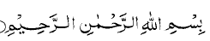
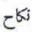 NIKAH – A Contract by Itself by Shaikh Abdool Aziz Shaikh
“Nuun, kaf, hah” (Arabic Verbal Root)
Nikahun means to bring together and gather together(according to Muheet) but actually to meet as sleep intermingles in the eyes; In Arabic  nakahan nu’aas is for sleep to fully intermingle in the eyes; or also means the way drops of rain water are absorbed in the ground. Thus nakahal matarul ard means: the rainwater was absorbed very well into the ground: Such statements are made when the rainwater almost reaches the water table in the earth. These explanations expostulate what the Qur’an means by Nikah when it talks about the family life of a woman and man, meaning, that the relationship between a husband and wife is like sleep has with the eyes i.e. to be immersed in each other like sleep is absorbed by the eyes or rainwater is absorbed in the ground. It is only such relationship that take place (in life) when both have homogeneity of thought, and temper and interests, ideology and concepts; this makes for the basic condition of Nikaah.

Obviously, for such a relationship to exist and prosper, mutual agreement must be the initial c condition. The Qur’an makes this clear in Surah 4 Verse 19 & Surah 4 Verse 6

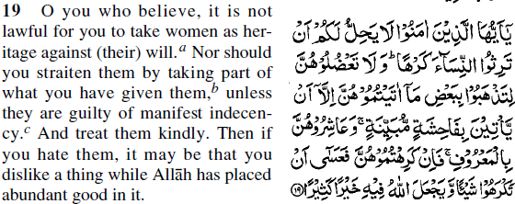

In the above Verse, 19, it is very clear that la yuhillu lakum it is NOT Halaal (if not Halaal then it must be Haraam) to take against their will.

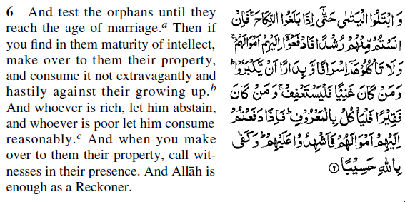
Mutual agreement can only take place when the husband to be and wife to be are both of age. The Qur’an says in the above Surah 4 Verse 6 that balaghun nikaah must be reached by both Marrying individuals as the above Verse further explains that they must be of maturity of intellect so that they can handle the rigours of the world.
The Qur’an further indicates in Surah 6 Verse 152 that 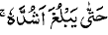 is attaining maturity and 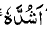again in Surah 17 Verse 34. In Surah 40 Verse 67, the process of gestation and old age is discussed and it is clearly stated 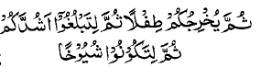 “He brings you forth as a child, then that you may attain your maturity, then that you may be old.” Thus the stage of “balagh” (age of marriage).Thus there is NO question of a non-adult boy entering neither Nikaah nor anyone on behalf of a non-adult girl expressing willingness of Nikaah. (Thus, it rules out child marriage or anyone giving consent on behalf of a girl for Nikaah): Raghib says Nikah means uqad (contract) and only conjugal relationship by extension. The Qur’an says:
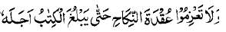 “wala t’azimu uqdatun nikkah hatta yablugha alkitaab ajalahu” Surah 2 Verse 235 “And confirm not the marriage contract 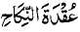until the prescribed period reaches its end”.

